**Life Management 1.0**

**User Manual**

**Authors: Beatriz Hernandez**

**Fernando Mojena**

Table of Contents

Users 3

Create Account 3

Change profile 6

Dashboard 6

Share Progress 8

Guest 8

Quiz 8

List of Coaches 8

Coaches 11

Login 11

Manage Profile 11

Chat 12

See User’s progress 12

Site Administrator Guide 13

Login 13

Create an Activity 14

Edit Activity 15

Delete Activity 16

Add a Life Coach 18

Approving Pending Activities 18

## Users

### Create Account

1- Click User Login link

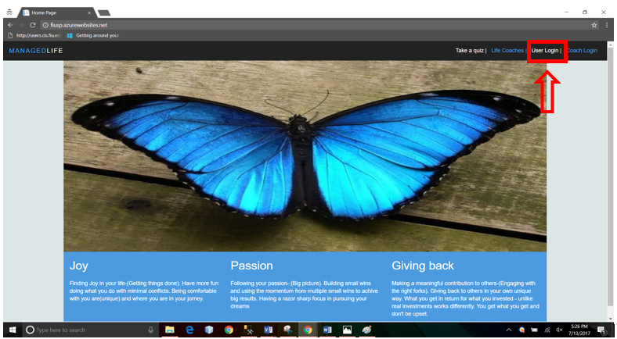

2- Click create Account

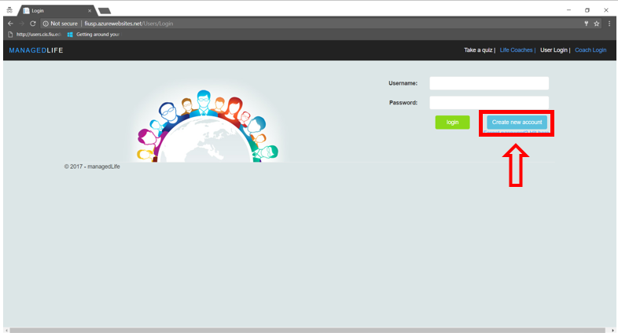

3- Fill out all fields and click save

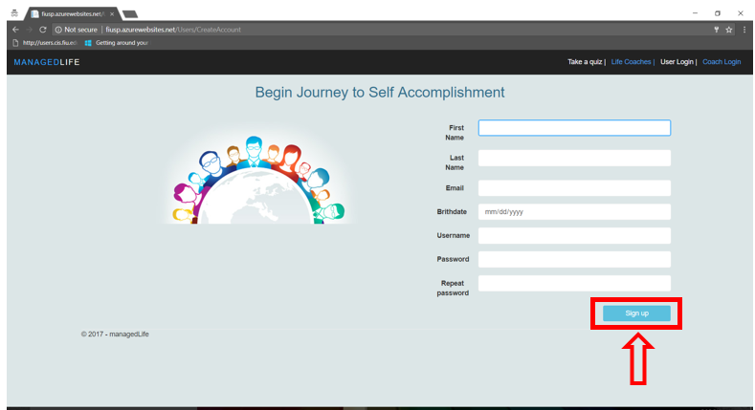

4- Complete initial questionnaire, click continue

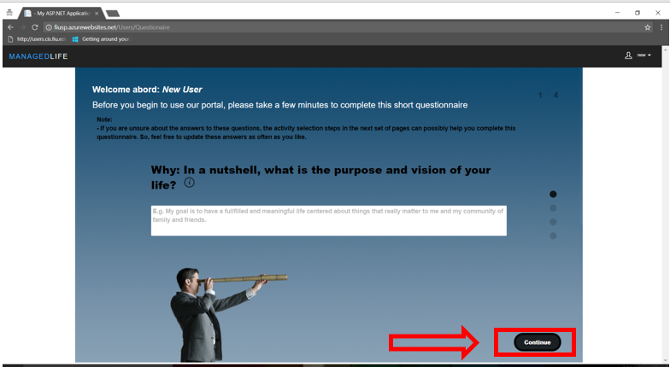

5- Click + button, and Choose 3 options here:

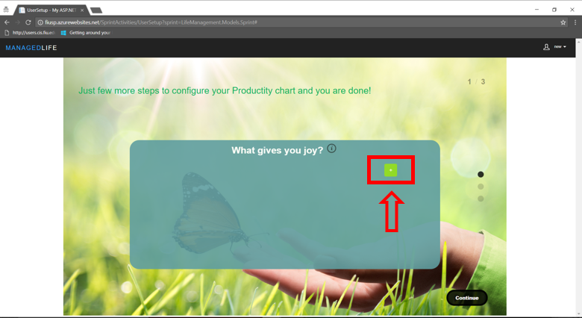

6- Select two options in the following 2 screens

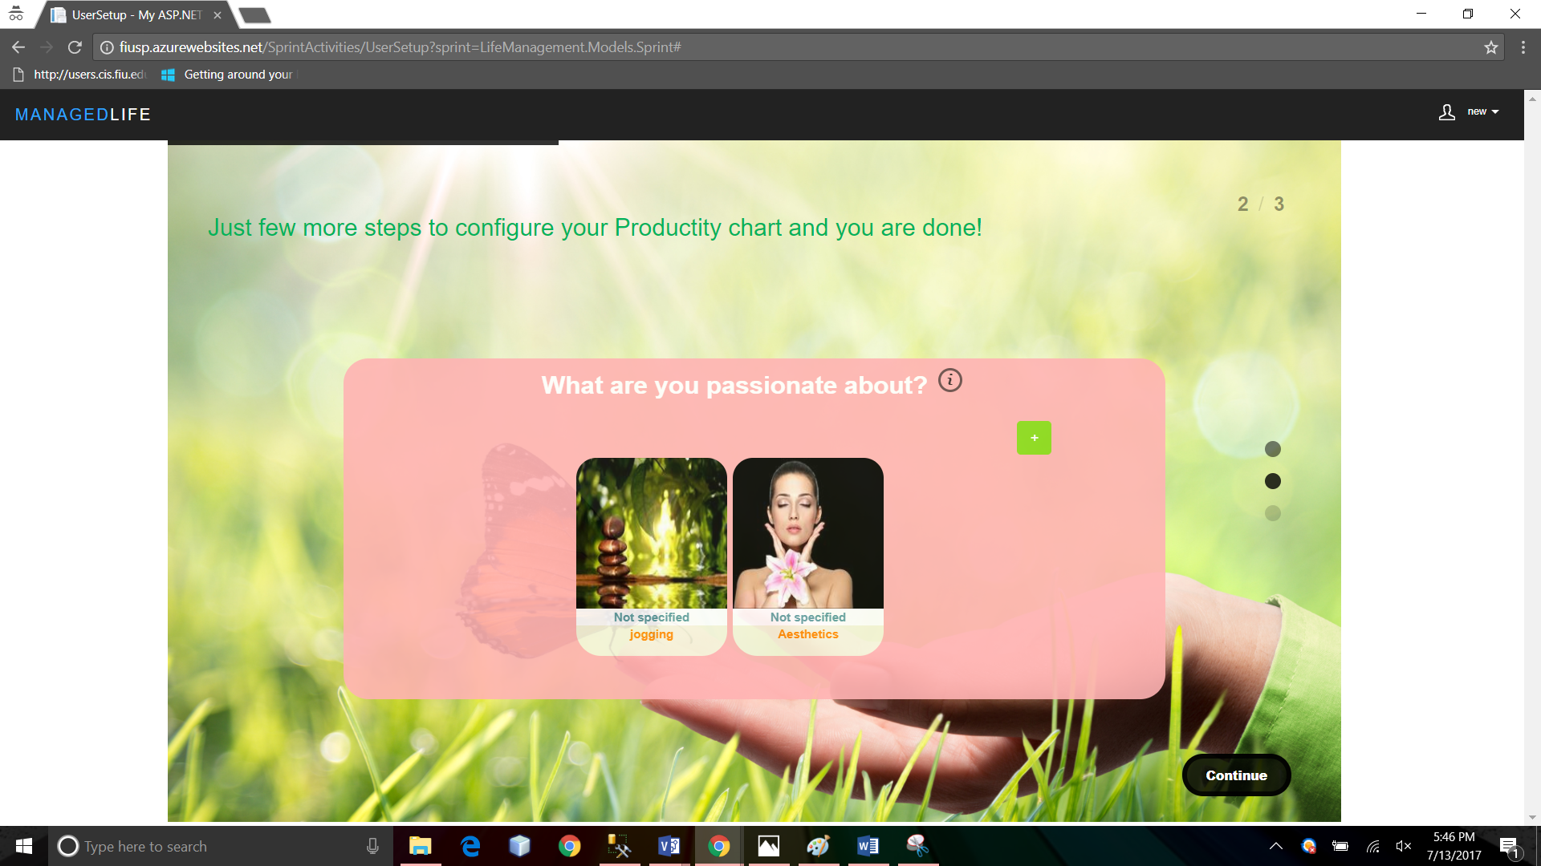

7- After configuring all your account, you’ll see your dashboard.

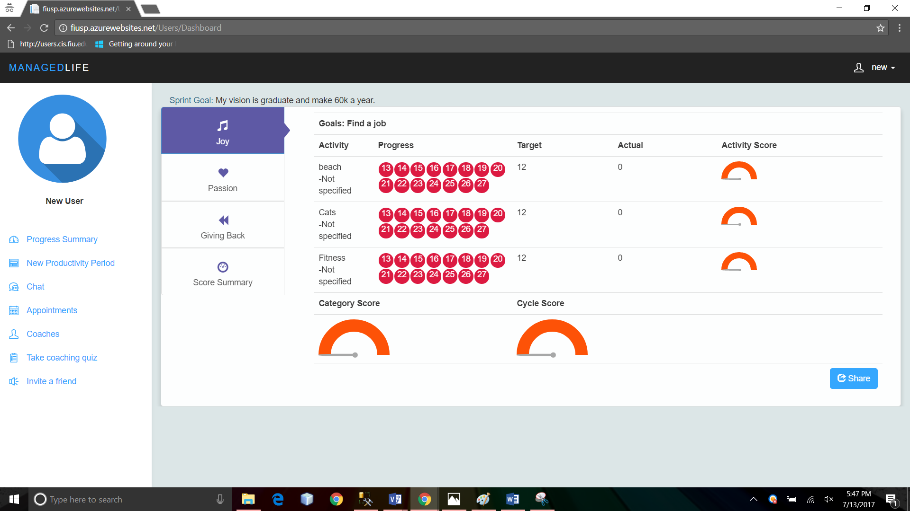

### Change profile

1- To change your personal information, click the profile link

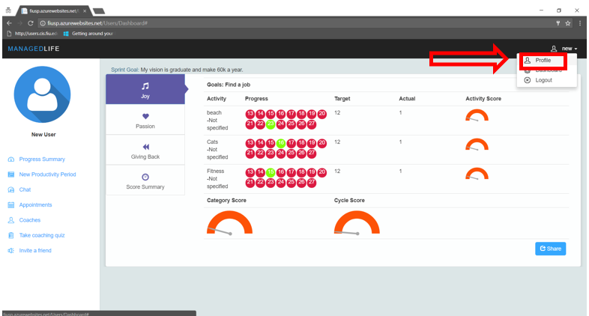

### Dashboard

- The panel on the left from top to bottom:

Progress summary: That is the home dashboard page, in the tabs to the right to can click on the calendar a day where you perform the corresponding activity. The circle representing the day, will turn green once selected. You can click any tab “Passion”, “Give Back” and “Score summary” to either register certain activity, or to check your progress.

New Productivity period: Use this link when you are not satisfied with your selected activities and want to start a new period.

Chat: Use this link to chat with your coaches and share files with them. (See picture below)

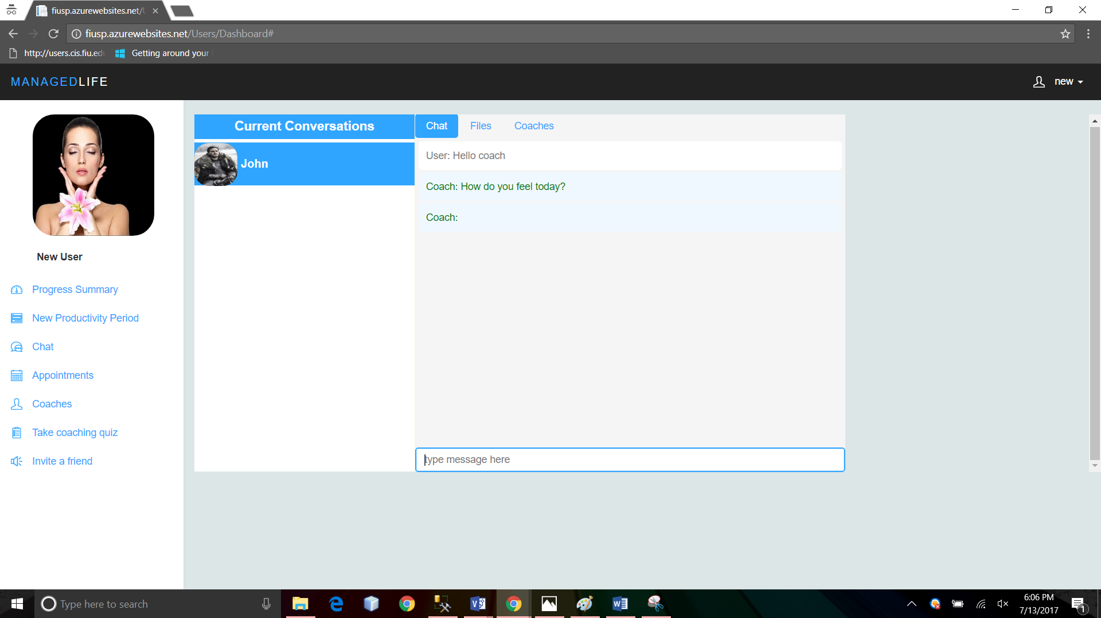

Appointments: Use this feature to schedule an appointment. (See picture below)

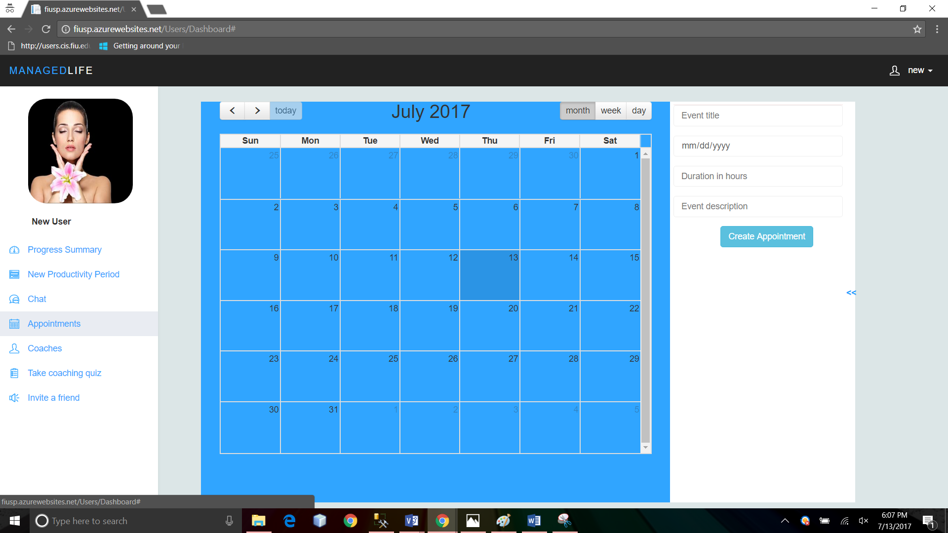

Coaches: There you can see a list of all available coaches in the system.

Take Coaching Quiz: Use this link to take a 12 question quiz, and find out whether you need a life coach in your life or not.

Invite a friend: Use this link to invite a friend to the application. The friend will receive an email with a link to the sign-up page.

### Share Progress

To share your progress in a certain category, or a summary of all of them, you can always click the share button, in the right bottom part of each tab, and follow instructions.(See screenshot). The coach will receive a copy of your progress in that category.

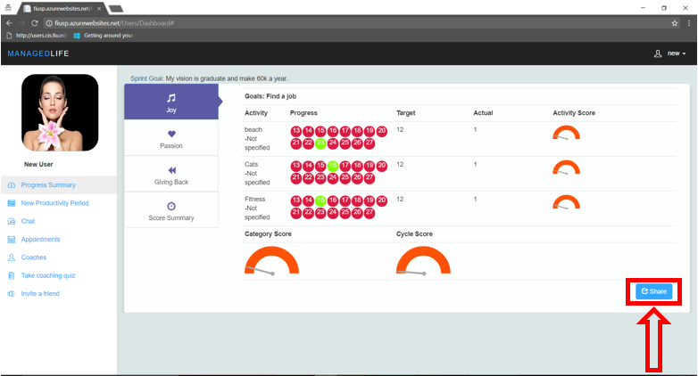

## Guest

### Quiz

1. Take the coaching quiz: Click the “Take a Quiz” link to take a 12 question quiz, and find out whether you need a life coach in your life or not. (#1 in screenshot below)

### List of Coaches

1. See list of available coaches: Click the “Life coaches” link, and a list of coaches with their personal information will appears. Quests are able also to see coaches reviews. (#2 in screenshot below)

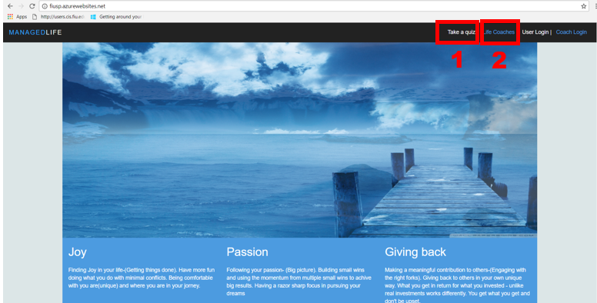

Take quiz Interface:

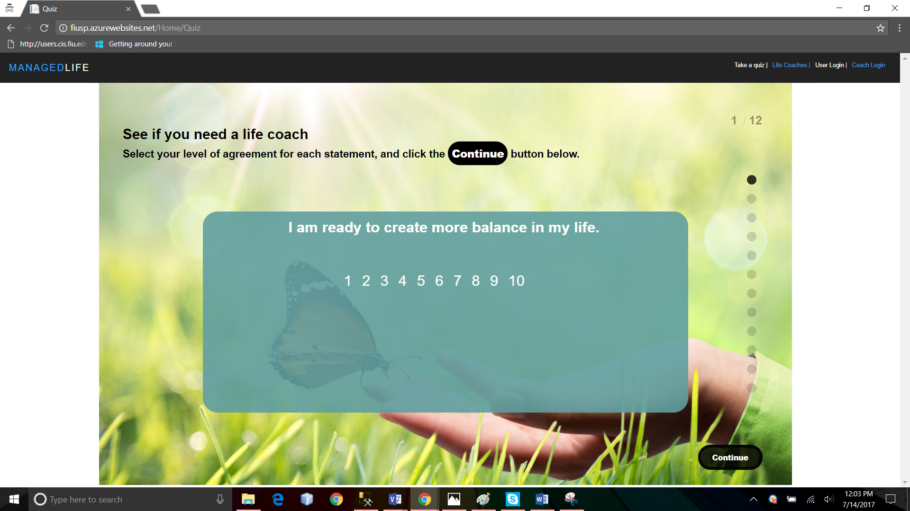

List of Coaches Interface:

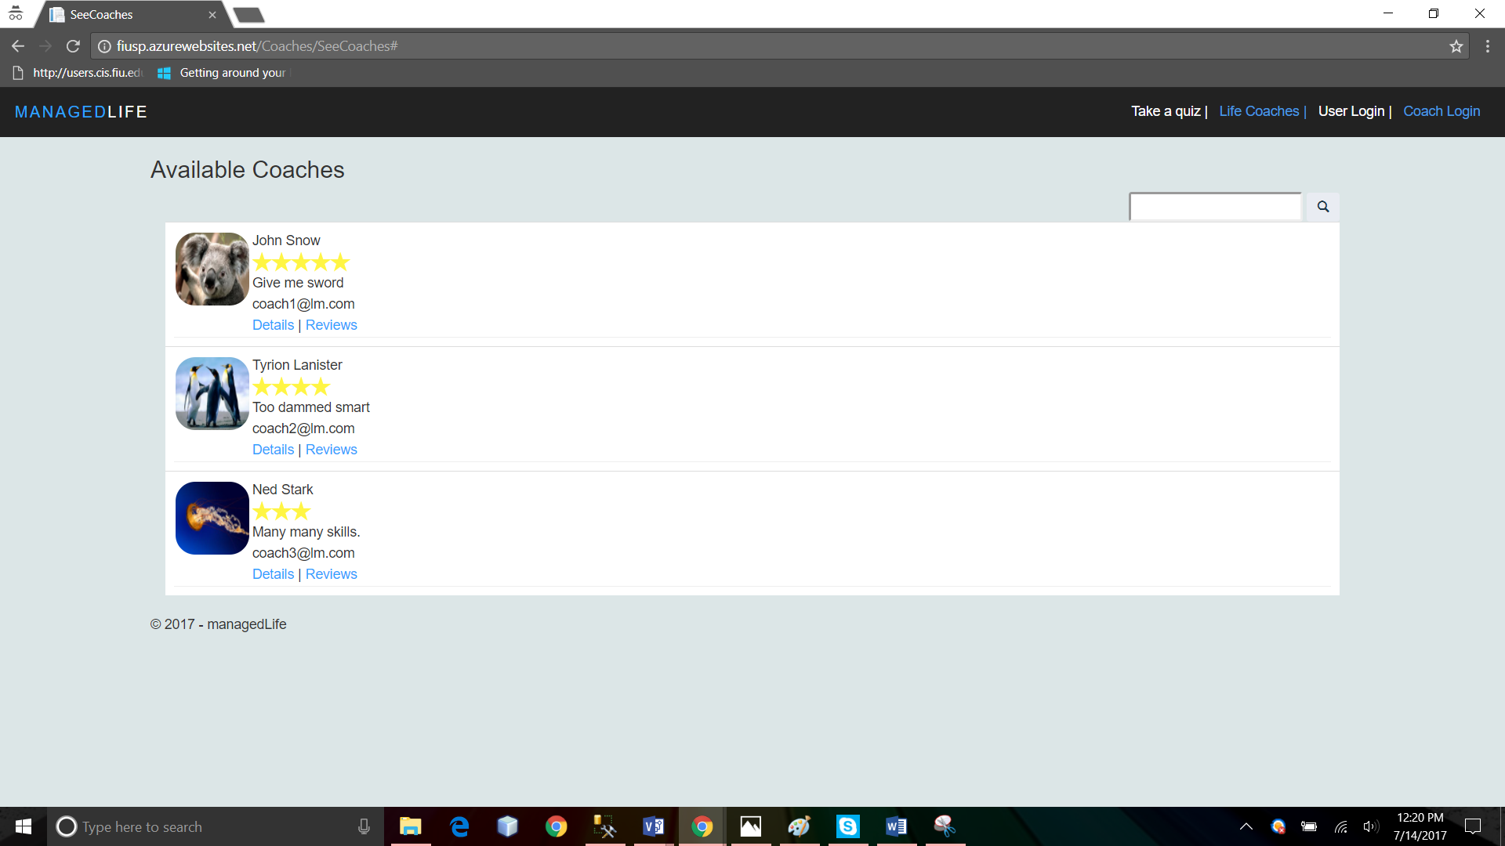

## 

## Coaches

### Login

1. Coaches can login using the “Coach Login” Link in the Main Page.

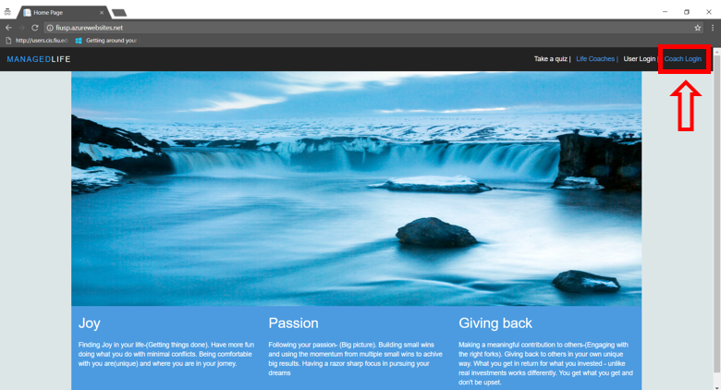

2- Login page: Coaches should enter the credentials provided by the site Admin who add them to the system.

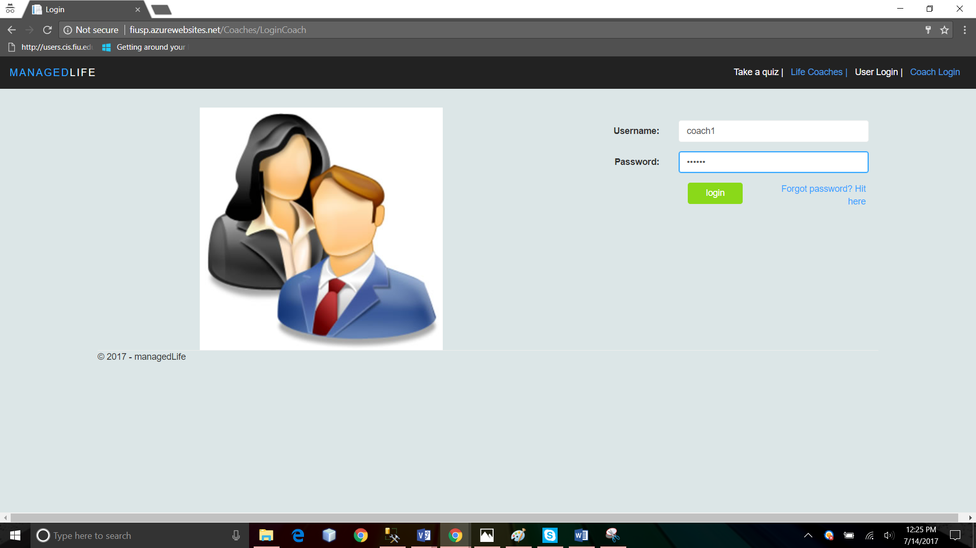

### Manage Profile

Same as User.( Refer to User Manual Above).

### Chat

From their dashboard, Coaches can chat with users, at users request.

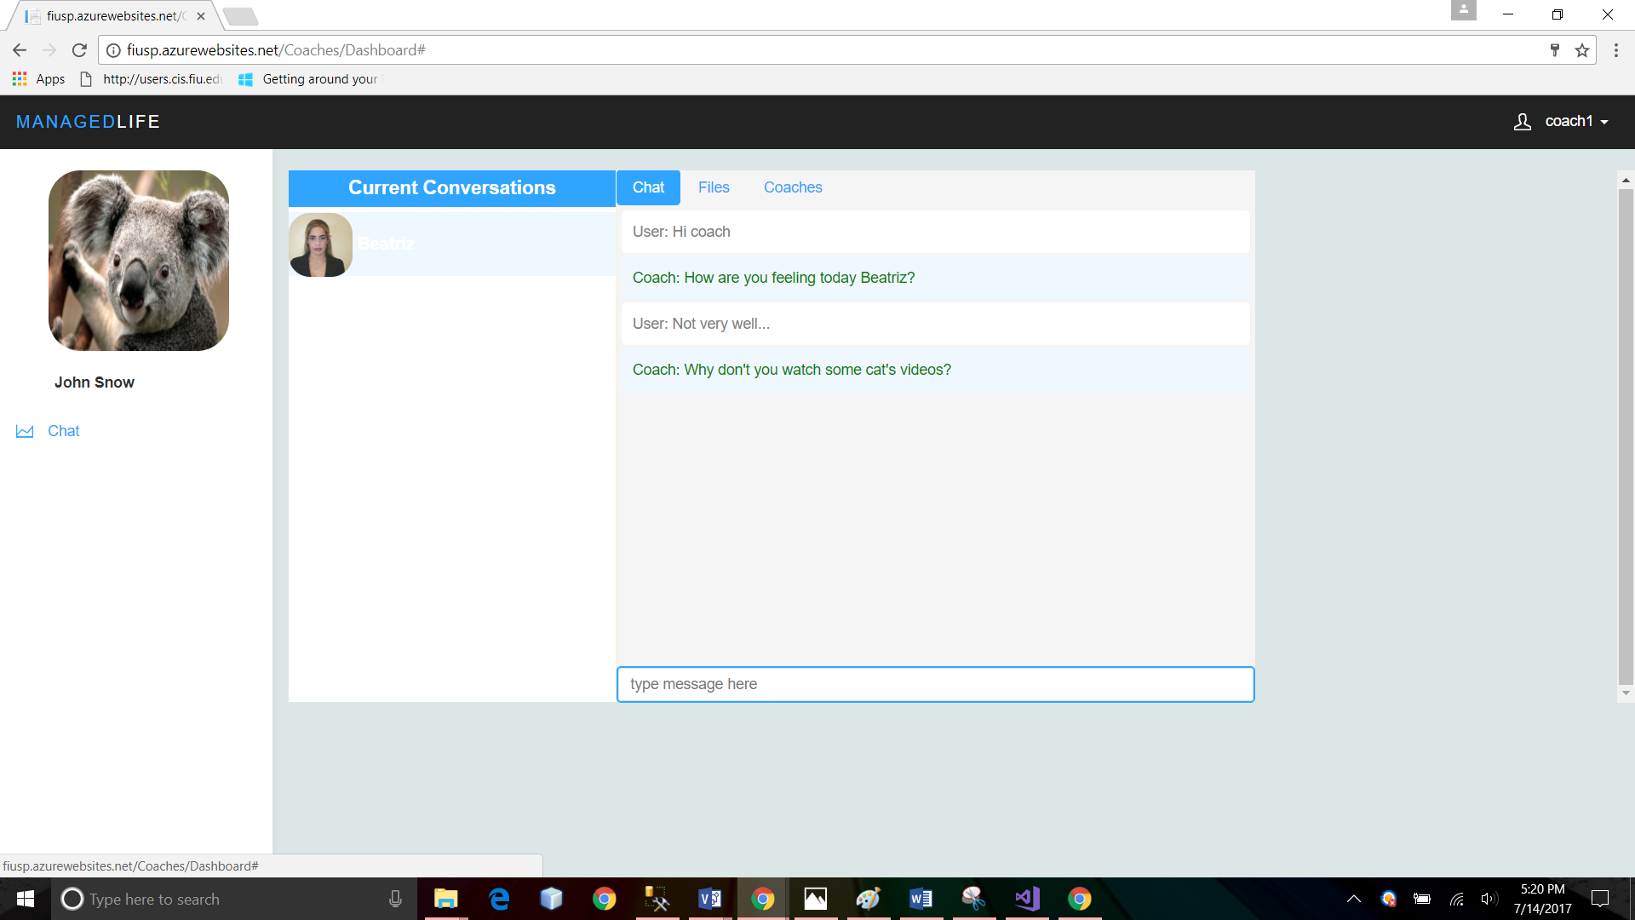

### See User’s progress

Coaches are able to see a live copy of the User’s progress for the period, at user’s request.

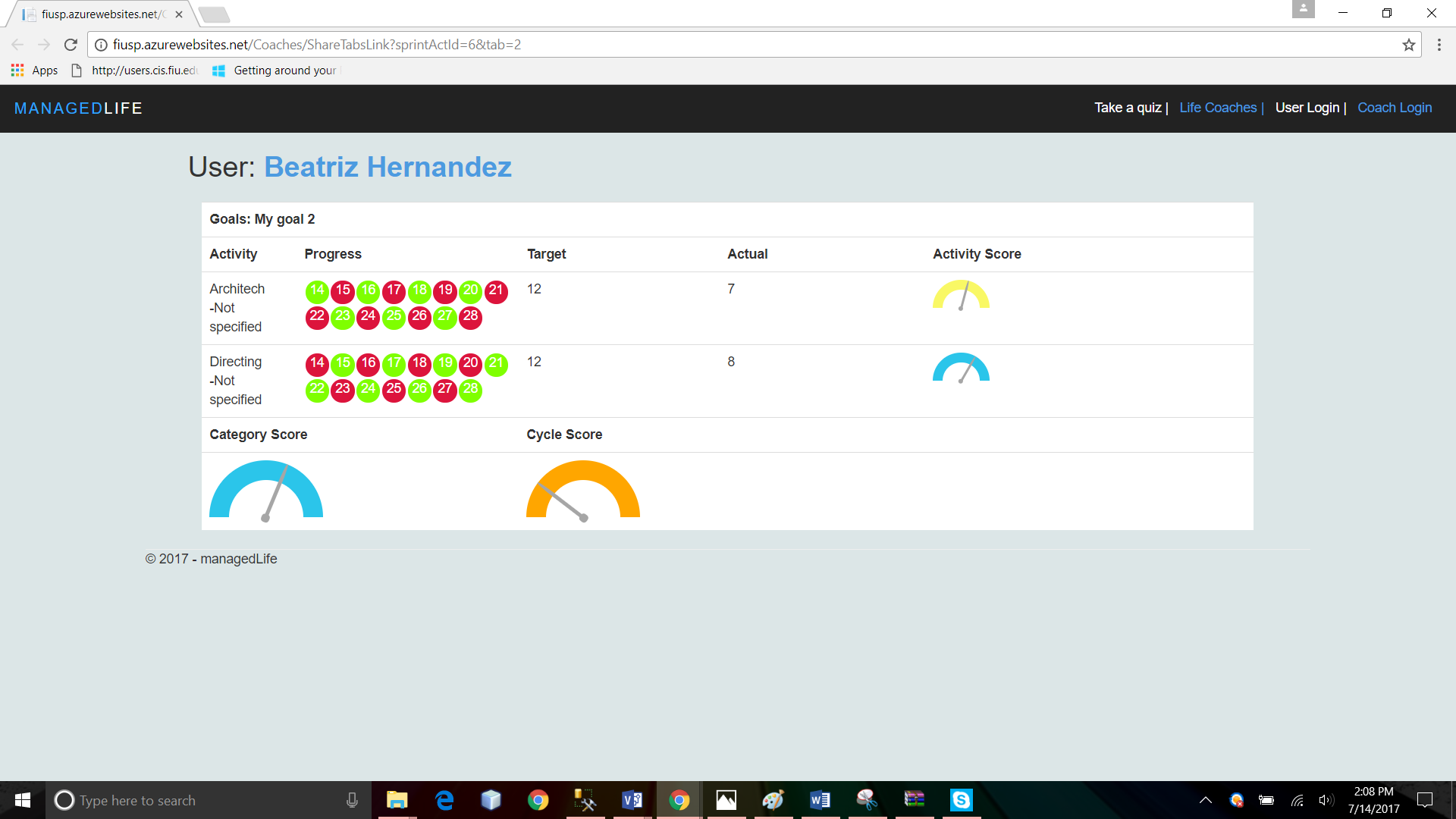

## Site Administrator Guide

### Login

As a site administrator,

1- Navigate to the website url: “fiusp.azurewebsites.net”

2- Click “User Login”

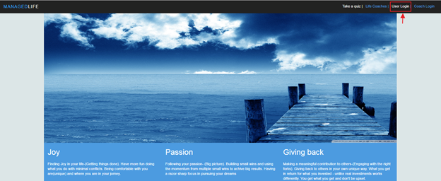

3- In the login page, enter your admin credentials and click “Login”

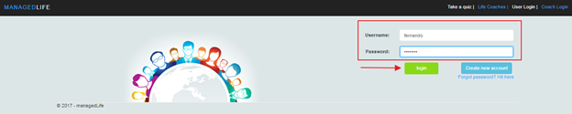4- The admin dashboard is presented

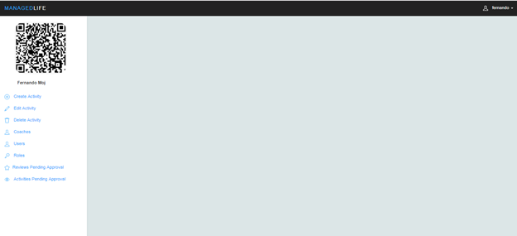

### Create an Activity

1- In the administrator dashboard, click “Create Activity” in the left navigation panel

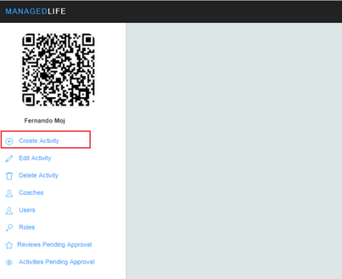

2- Provide name, category and browse your PC for an image, then click “Create”

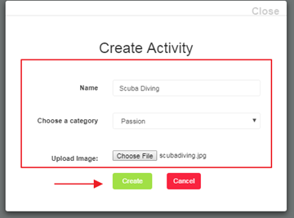

3- Confirmation is displayed

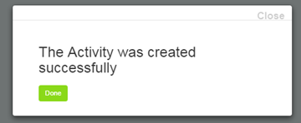

### Edit Activity

To edit an existing activity,

1- click the “Edit” link the left navigation panel

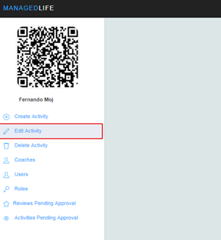

2- In the popup window, select the desired category and then click the activity to be edited:

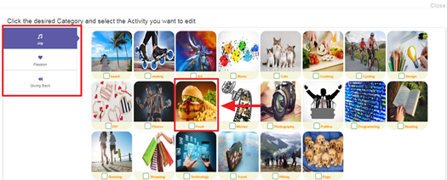

3- Update the desired information and click save

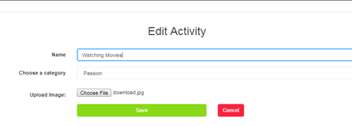

4- Confirmation is displayed

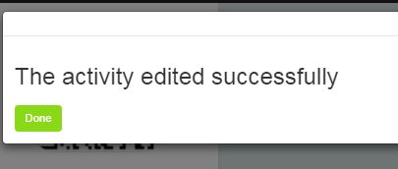

### Delete Activity

To delete an existing activity,

1- Click the “Delete Activity” link in the left navigation panel

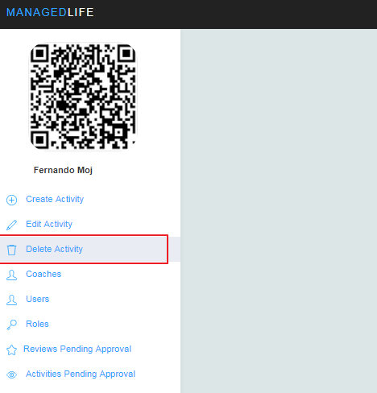

2- Select the category and activity you wish to delete

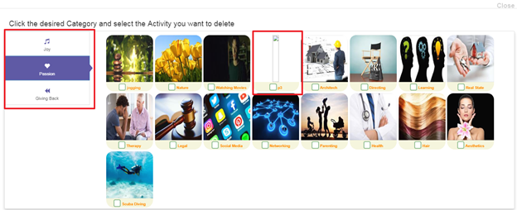

3- Confirm deletion

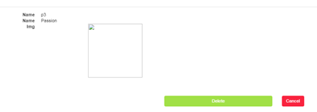

4- Success message appears:

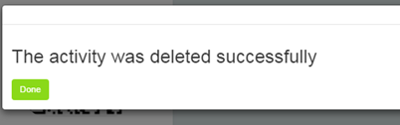

### Add a Life Coach

To add a coach,

1- Click the coach link in the left menu and then the “Add New” button

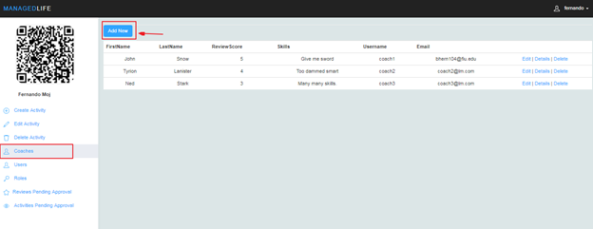

2- Provide information requested and click “Create”

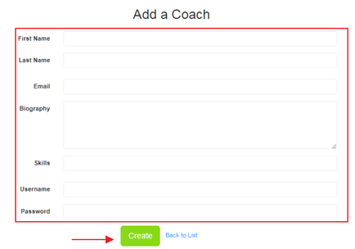

### Approving Pending Activities

To approve and make available to everyone user created activities

1- click the “Activities Pending Approval” link the left menu

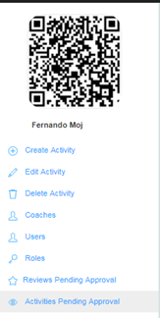

2- Click a pending activity in the list

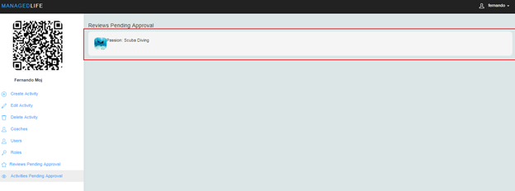

3- Click approve or reject on the popup window

